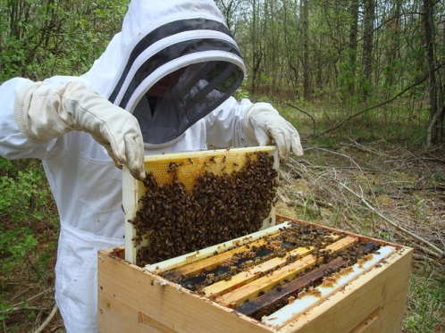
Nash County Farm Bureau Beginner Bee Keeper Grant Program
Objectives:
- To teach youth the art of beekeeping and educate them on the
importance of honeybees to our environment and food supply.
- To provide youth with an opportunity to learn responsibility while
experiencing the joys and challenges of beekeeping.
- To educate youth on the income potential of beekeeping so they can determine whether to pursue it as a part time or full time vocation.
The Award:
- Nash County Farm Bureau will provide hardware and necessary tools for one hive of honey bees.
- In addition the Nash County Farm Bureau will provide a 3 lb. package of honey bees or a nuc with a marked queen.
- The recipient will provide their protective outerwear.
Eligibility:
- The applicant must be new to beekeeping and must between the ages of 14 and 30 years old.
- The applicant or his/her parents must be members of Nash County Farm Bureau.
- Must be a resident of Nash County
- The applicant must have permission and support from their parent or guardian if applicable.
- The applicant must live in or have access to an area that allows beekeeping.
- The applicant must not be allergic to bee stings.

- The applicant must be willing to return equipment furnished by the Nash County Farm Bureau if he/she decides they are unable to manage the bees or they lose their hive and do not wish to obtain another hive and stay in beekeeping.
If this occurs please contact Ken Powell as soon as possible.

Call Ken Powell @ 252-813-1406 you have any questions.

