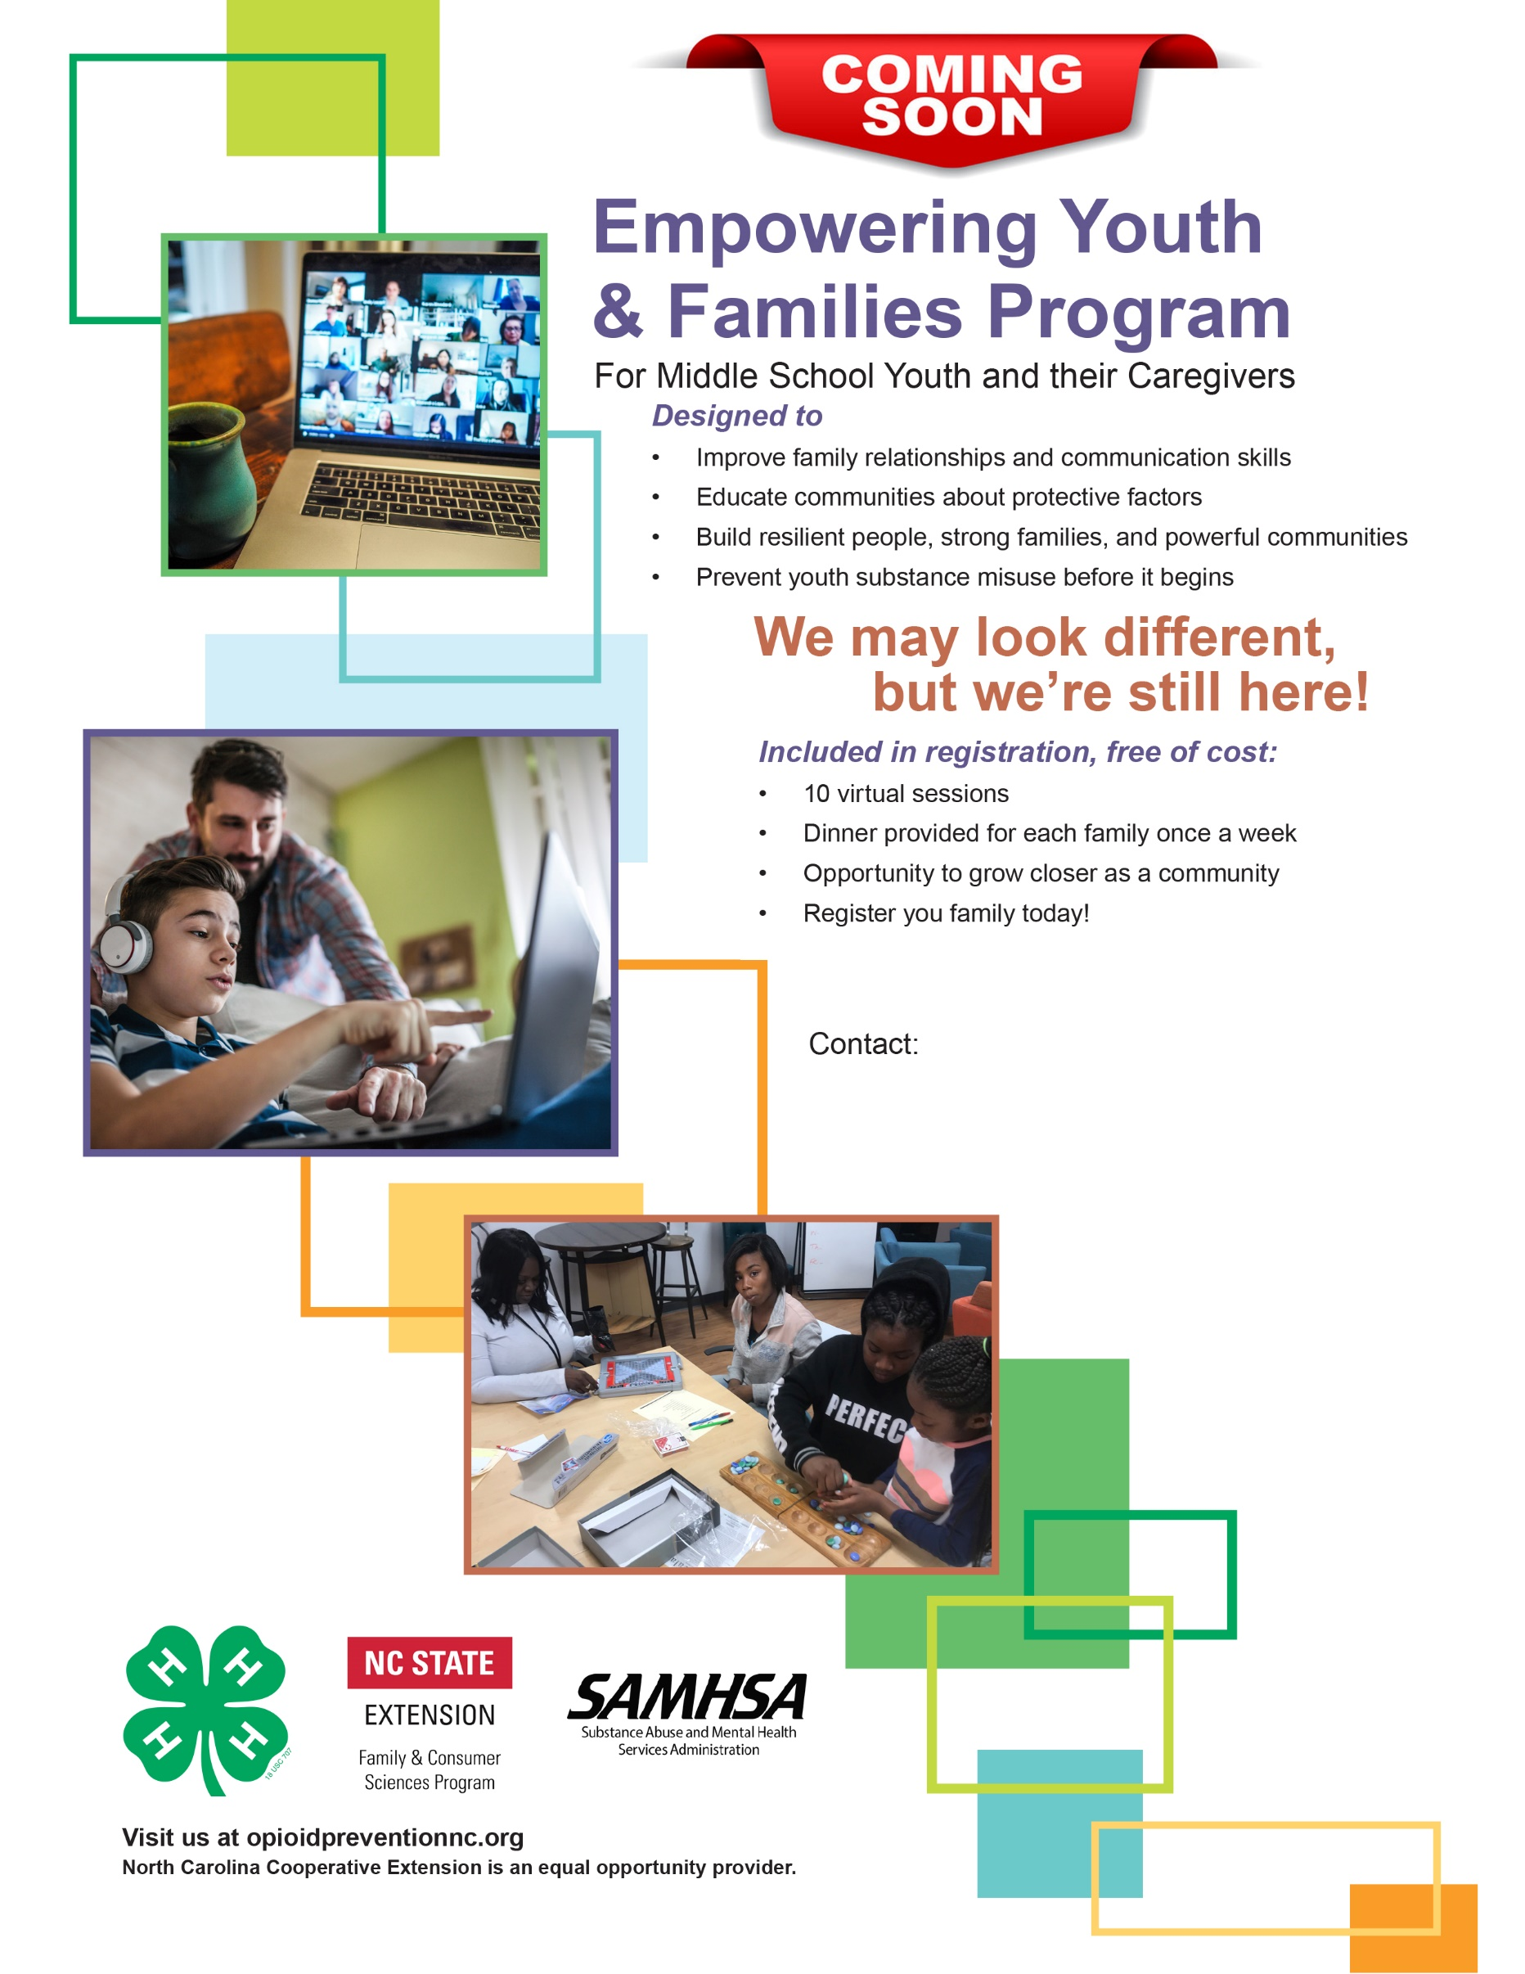

Register your family today

**Join us for**

**Virtual Open House**

**10/20/2020 @ 6:00**

**And learn more**

**252 459 9810**

**Adrienne Williams**

Empowering Youth and Families Program Assistant

Nash County Cooperative Extension

1006 Eastern Avenue, Room 102

Nashville, NC 27856

[adwill23@ncsu.edu](mailto:adwill23@ncsu.edu)