North Carolina 4-H
Project Record Report Form
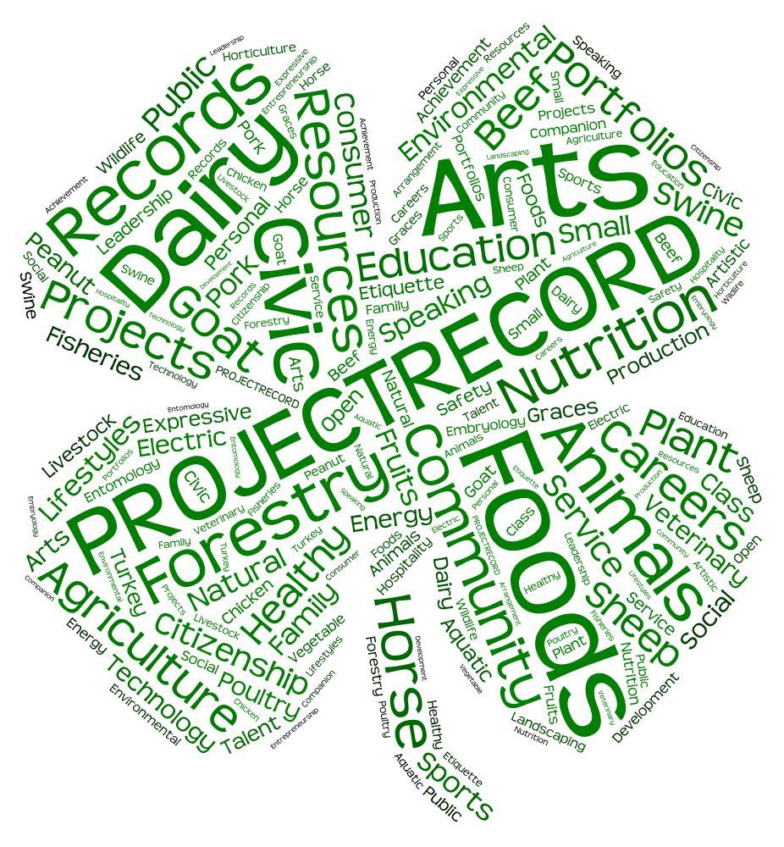
Age Categories:
13–15 & 16-18

North Carolina 4-H Project Record Guidelines

- Each 4-H member should complete their 4-H Project Record to the best of their ability and turn it into their county 4-H agent by the county due date.

- Project work should be reported for one year. You may add additional pages to the report form in sections 1, 3, 4, 5, 6, 7, 9, 10. All information should only be listed once in the report form. This means you may have to choose the BEST place to report information.

- All materials are property of North Carolina 4-H and may be used to showcase 4-H work but will not contain your personal information.

Guidelines for completing your records:

• Use this form as a guide for completing your record book. If you choose to type your record, feel free to use a word processing program. We do ask that you list the Section Number and Title at the top of the page.

• In the upper right hand corner of the outside cover, please include the following information: Name, County, District, Project Record Category, and Age Category.

• Place your Project Record in a 3 prong report folder (No 3 ring binders please).

• Please print legibly or type using Arial or Times New Roman font in size 12 ONLY. See link below for the form to download:

http://www.nc4h.org/youth/4-h-awards-incentives-programs

Guidelines

Your 4-H Project Record should have all 10 sections of the book in consecutive order and should only include things from THIS YEAR (January 1 – December 31).

Section 1 – Personal Data and 4-H & You page
Please be sure to complete all of the information requested on this page. Do not forget to list your Project Record Category. Make sure the appropriate people sign your Project Record.

Section 2 – My 4-H Story
Write a story about your 4-H experiences, including what you’ve done, learned, and enjoyed. Your story should be no more than 4 pages. It can be typewritten or printed neatly. It should include your 4-H experience for this year in the story. Introduce the judges to who you are. See specifics in Section 2.

Section 3 – 4-H Project Focus
We "learn by doing" in 4-H. List the specific things you learned and did in this project area this year. Project work is from January – December. List knowledge and skills gained as well as the things you learned how to do. Use numbers to show how much you did and learned. Please list the most important presentations, talks, exhibits, radio, TV, newspaper articles, tours, camps, judging events, workshops, and any other learning experiences in which you have participated related to your project. You should only include 4-H work completed in one program year.

Section 4 – Leadership
This page is where you should list all the leadership activities in which you have participated. Be specific – list the number of people you taught and the name of the lesson. Leadership involves holding offices and serving on committees. It can also involve teaching workshops, volunteering at 4-H day camps, leading/facilitating club programs, organizing events and meetings, recruiting new members, serving as a 4-H Ambassador, and motivating peers to set a goal and take action. List ways you have been a leader and/or have learned about leadership. If you are listing non 4-H leadership activities, please list only those for which 4-H has helped you prepare. You should only include 4-H work completed in one program year. If your 4-H project focus is on Leadership you may write “See Section 3” as your answer in this section or use it to continue adding project work for Section 3.

Section 5 – Citizenship
As teenagers, it is important to participate and be involved in the political process and make a civic contribution in our communities. Citizenship activities might include: attending a town meeting where you were representing 4-H; sending a message to your state legislator about
4-H teen issues that have been identified on the state 4-H program level; promoting 4-H and Cooperative Extension to county commissioners or other government representatives, etc. If you are listing non 4-H citizenship activities, please list only those for which 4-H has helped you prepare. You should only include 4-H work completed in one program year. If your 4-H project focus is on Citizenship you may write “See Section 3” as your answer in this section or use it to continue adding project work for Section 3.

Section 6 – Community Service
Community service involves contributing to the quality of life in your community. Like many
4-H'ers, you may have participated in community service activities for your club or by yourself. Examples may include: volunteering at your local animal shelter, participating in a food drive, holding a fundraiser for your 4-H club, etc. List the number of hours you volunteered and who benefited from your volunteer service. If you are listing non 4-H Community Service activities, please list only those for which 4-H has helped you prepare. You should only include 4-H work completed in one program year. If your 4-H project focus is on Community Service you may write “See Section 3” as your answer in this section or use it to continue adding project work for Section 3.

Section 7 – 4-H Awards and Recognition
List certificates, ribbons and other awards you have won in the past year. Remember, only 4-H winnings go on this page! Specify whether they were National, Regional, State, District, County or Club awards. Experiences should be divided out between project specific awards that related to this Project Record area and other 4-H awards.

Section 8 – Non 4-H Experiences, Awards, and Recognition
List any other groups, clubs, organizations, or sports teams to which you belong, as well as other items that have had a significant impact in your life, such as camps, conferences, or a job. You may also list any awards you have won or recognition you have received outside of
4-H. Examples of activities you may have been involved in would include: school clubs, VBS, Girl Scouts, Boy Scouts, FFA, etc.

Section 9– 4-H Photos and Supporting Materials
Include up to six 4-H scrapbook pages, which may include pictures (with captions), news clippings, letters, certificates, poems, teaching tools, short stories, digital media, etc. Be sure to follow the guidelines closely especially the page limits.

Section 10– 4-H Goals Setting for the next year
In order to get the most out of your 4-H Project experiences, members must be actively involved in developing what their 4-H projects will be, set their own goals and making decisions on when and what they will do to accomplish their goals. Goals basically represent what your next “destination” will be. If your goals are well written, they will help members, parents, leaders and agents know exactly where you want your 4-H project to go. Your goals should have the following parts: “I want”; Action; Results; and a Timetable. You will develop the goals for the next year in your 4-H projects.

ACTION: How you will do something?
RESULTS: What you are going to do?
TIMETABLE: When you are going to do it.

Question to think about as you develop your goals for the next year in 4-H.
What are some things I really like to do?
How good am I already at these things?
How much do I know about this already?
Is there one thing I’d like to learn more about or learn to do better?
Are there completely new things that I want to learn or do?

A goal is:
- the point you strive to reach
- completed by a designated time
- short term or long term
- an ideal to strive towards, sometimes so far up, it is impossible to reach from the point you are now; but the point is by trying and working hard, you can obtain that goal.

ACTION RESULTS TIMETABLE
I want to learn how to eat healthier by December.
I want to give a 4-H presentation at DAD by June.
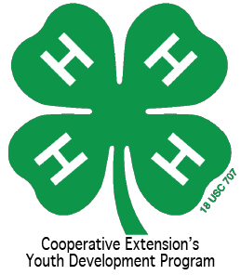
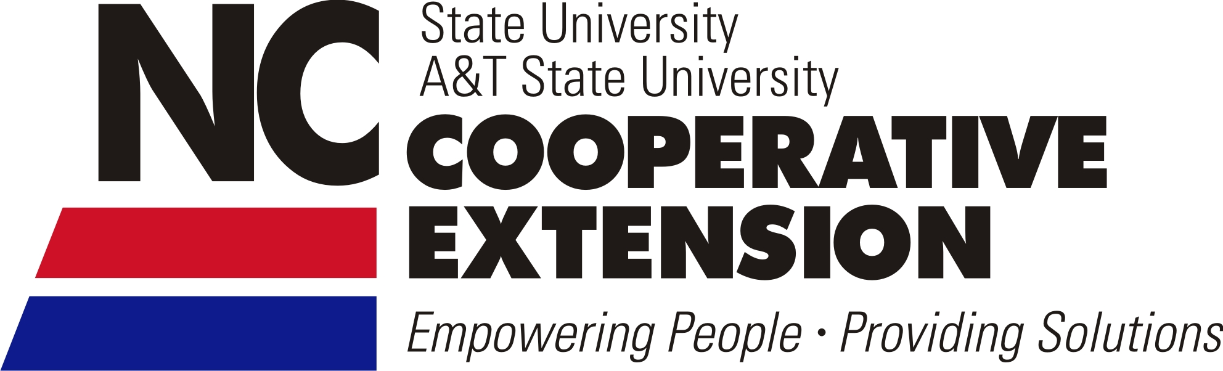
I want to train my do to sit and stay before summer is over.
North Carolina 4-H Project Record
For More Information contact:
Shannon McCollum
Extension 4-H Associate
shannon_mccollum@ncsu.edu
(919)515-8486
www.nc4h.org

A Message to 4-H’ers:
Introduction
Records are an important written summary of what you have learned and the skills that you have gained within your 4-H work, as well as in other parts of your life. Over a period of years your records will show how you have grown. The information on your 4-H records will be useful as you fill out other forms in your life such as 4-H Porfolio’s, resumes, job applications and college applications.
- Record keeping is an important part of every 4-H educational project.
- Many awards, educational trips, and college scholarships are given to club members on the basis of their records and project work.
- Records show your 4-H growth. You may include 4-H work completed in one program year.
- This form is designed to help you keep records and other supporting materials in an orderly manner.
- Do not alter the basic format of this book.
- You may hand write neatly or type in size 12 Arial or Times New Roman font.

Your 4-H Project Record should contain the following sections:
Section 1 Personal Data and 4-H & You
Section 2 4-H Story
Section 3 4-H Project Focus
Section 4 Leadership
Section 5 Citizenship
Section 6 Community Service
Section 7 4-H Awards and Recognition
Section 8 Non 4-H Experiences, Awards, and Recognition
Section 9 4-H Photos or Supporting Materials
Section 10 4-H Goals Setting

SECTION 1: Personal Data
County You Participate In 4-H: ______________ Program Year: _______

4-H Project Record Category in which you are entering: _________________________________

Competition Category: 13 thru 15 years old 16 thru 18 years old
(age as of Jan. 1 for the project reporting year)

Number of years in the above program area: _____ Years in 4-H: _____

Name: __________ __________ __________ Male Female
(first) (middle) (last)

Name you want used in publicity: ______________________________________
(please print)

Home Mailing Address: ______________________________________

City: ______________________ State: ________ Zip Code: __________

Primary Telephone Number (include area code): ______________________________________

Date and Year of Birth: __________ Age as of January 1: __________
(age as of Jan. 1 for the project reporting year)
Names of parents or guardians: _______________________________________________

Name of your 4-H club or group: _____________________ 4-H’ers Primary email address: _________________

Name of School: __________________ Grade in School: __________________

Prior 4-H Project Record Gold awards won in this category Gold Year:
for this age group:

STATEMENT BY 4-H MEMBER
I give North Carolina 4-H permission to use my record as a sample, after identifying information has been removed, and allow North Carolina 4-H to use my Digital Media if any is provided to use for 4-H Marketing opportunities. I also understand that North Carolina 4-H will contact me before any of my information is shared.

I have personally prepared this report and certify that it accurately reflects my work:

Date: ____________, 20 ___________ Signature of 4-H Member: _____________________________________

APPROVAL OF THIS REPORT

We have reviewed this report and believe it to be correct:

Date: _______________, 20________ Signed: ____________________________________________________
(Parent or guardian)
Date: _______________, 20________ Signed: ____________________________________________________
(Local 4-H Leader)
Date: _______________, 20________ Signed: ____________________________________________________
(County Extension Agent)

4-H & YOU!
Answer questions on separate paper if needed. Please retype the questions
Looking back over the past year in 4-H:

1. Discuss your favorite thing about 4-H. It does not have to relate to the project reported in Section 3.

2. Who is your role model in 4-H? Why?

3. Discuss the most important thing you have learned during the past year in 4-H.

Looking to the future:

4. If you were in charge of 4-H, how would you make it better? In your:

County:

District:

State:

SECTION 2
My 4-H Story
(Place your 4-H Story behind this page)

Your story is limited to no more than four (4) pages typed or handwritten. Your story should include all of your 4-H projects for this year.

Suggestion of things to include in your story:

Introduce yourself and include any information you choose to share about your interests, family, hobbies etc. Think about this as what would you say if you were given two minutes to introduce yourself.

Describe the impact 4-H has had on your life.

How has participating in the project you are completing in this Project Record impacted your personal growth?

Who has helped you in your 4-H journey?

How has your 4-H participation helped others?

What are your goals in life?

Summarize your experiences in 4-H.

Sections 3-5 of this record book can help you.

Program Year:_____

SECTION 3
4-H Project Focus

(Name of 4-H Project)

- We “learn by doing” in 4-H. List the specific things you learned and did in this project area during the past year.
- List knowledge and skills gained as well as the things you learned how to do. Use numbers to show how much you did and learned.
- Please list the most important presentations, talks, exhibits, camps, judging events, workshops, or any other learning experiences in which you have participated related to your project. Include dates and level of participation.
- Please list the work you have done this year (from January – December) using a bullet statement, list, and/or chart.

Activity & Date | Knowledge/Skills Gained from this Activity | Level
Attended 4-H Congress-July 25-28, 2016 | Completed soil tester kit and learned to solder. | S
When completing your project record or portfolio, you may delete examples above.

(Attach pages here)

Savings, Profits, Losses
If applicable, please list your savings, profits, and losses when appropriate in this section.

*Level = L - Local, C - County, D - District, S - State, R - Regional, N - National

Program Year:_____
SECTION 4
Leadership

- List all leadership activities in which you have participated.
- Be specific – list the number of people you taught and the name of the lesson (when applicable).
- Leadership involves holding offices and serving on committees.
- It can also involve teaching workshops, volunteering at 4-H day camps, leading/facilitating club programs, organizing events and meetings, recruiting new members, serving as a 4-H Ambassador, and motivating peers to set a goal and take action.
- List ways you have been a leader and/or have learned about leadership.

Please denote 4-H Leadership activities with an asterisk. If you are listing non 4-H Leadership activities, please list only those for which 4-H has helped you prepare.

*Level = L - Local, C - County, D - District, S - State, R - Regional, N - National

Activity | Accomplishment/Hours | Level
4-H Club presentation (TAUGHT workshop) | 15 members learned about presentations | L
4-H County Council Meeting (TAUGHT workshop) | 28 club members learned how to make a healthy snack | C
4-H Club President | Led monthly meetings/12 hours | L
Coordinated service project at nursing home | 75 residents participated/5 hours | C
When completing your project record or portfolio, you may delete examples above.

(Attach pages here)

Program Year:_____
SECTION 5
Citizenship
Citizenship
Responsible citizenship is an individual's demonstration of love and devotion in response to duties, rights and privileges as a member of a community or country. It includes loyalty to one's place of residence (city, state, county. country); the entitlements and privileges of citizenship, including voting, protection, participation in government; obligations of citizenship; learning about history and celebrating historical and cultural events; and appreciating and valuing diversity.
- As teenagers, it is important to be civically engaged and make positive contributions in our communities. One way to do this is by participating and being involved in the political process;
- Citizenship activities might include: attending a town meeting where you were representing 4-H; sending a message to your state legislator about 4-H teen issues that have been identified on the state 4-H program level; promoting 4-H and Cooperative Extension to county commissioners or other government representatives; etc.
- Please denote 4-H Citizenship activities with an asterisk. If you are listing non 4-H Citizenship activities, please list only those for which 4-H has helped you prepare.

*Level = L - Local, C - County, D - District, S - State, R - Regional, N - National

Description of Activity and or Accomplishment | Level
*Attended 4-H Youth Summit | S
*Attended County Commissioner Meeting | C
*Recognition by local government/county commissioners for holding flag retirement ceremony | L, C
Researched Candidates and watched debates on TV | L
*Participated in a workshop on flag etiquette | S
Toured NC Museum of History | S
Visited National Monuments in Washington DC | N
When completing your project record or portfolio, you may delete examples above.

(Attach pages here)

Program Year:_____

SECTION 6
Community Service

- List the community service activities you have participated in as a 4-H’er.
- Community service involves contributing to the quality of life in your community.
- Like many 4-H'ers, you may have participated in community service activities for your club or by yourself. Examples may include: volunteering at your local animal shelter, participating in a food drive, holding a fundraiser for your 4-H club, etc.
- List the number of hours you volunteered and who benefited from your volunteer service.

Please denote 4-H Community Service activities with an asterisk. If you are listing non 4-H Community Service activities, please list only those for which 4-H has helped you prepare.

*Level = L - Local, C - County, D - District, S - State, R - Regional, N - National
Examples

Activity | Hours | Level
Donated 2 bags of canned goods for Food for Families Food Drive | 2 | L
Writing letters to soldier | 2 | N
Made no sew blankets for the homeless shelter | 5 | C
Picked up trash at local park | 2 | L
Packed 10 book bags for Backpack Buddies | 5 | C
Packed food bags at 4-H Congress for Feeding Children Everywhere | 3 | S
When completing your project record or portfolio, you may delete examples above.

(Attach pages here)

Program Year:_____

SECTION 7
4-H Awards and Recognition

- List all the awards, honors, and recognitions you have received in 4-H, including contests, trips, certificates, ribbons, etc. Remember, only 4-H winnings go on this page! Specify whether they were National, Regional, State, District, County or Club awards.
- Experiences should be divided out between project specific awards that related to this Project Record area and other 4-H awards. List your Project specific awards first then follow with other awards for each page.

If you have not received any awards, do not leave the section blank. Instead write “No Awards Received”.

Project Awards

Award/Recognition | For What Received | Level
Gold Medal | Electric Portfolio | D,S
Certificate | Duke/Progress County Delegate | C
When completing your project record or portfolio, you may delete examples above.

Other 4-H Awards

Award/Recognition | For What Received | Level
Certificate of Participation | Attendance State 4-H Marsh Maneuvers | S
Certificate & Blue Ribbon | Area Commodity Ambassador
When completing your project record or portfolio, you may delete examples above.

(Attach pages here)

*Level = L - Local, C - County, D - District, S - State, R - Regional, N – National

Program Year:_____

SECTION 8
Non 4-H Experiences

- List any other groups, clubs, organizations, or sports teams to which you belong, as well as other items that have had a significant impact in your life, such as camps, conferences, or a job.

Participation Level/Accomplishments
Youth Praise Team member
Captain of Softball Team
When completing your project record or portfolio, you may delete examples above.

Non 4-H Awards & Recognition

- You may also list any awards you have won or recognition you have received outside of 4-H. Examples of activities you may have been involved in would include: school clubs, VBS, Girl Scouts, Boy Scouts, FFA, etc.

Type of Award/Recognition | For What Received
Plaque – 1st place | Community Beautification poster contest
When completing your project record or portfolio, you may delete examples above.

If you have not received any awards, do not leave the section blank. Instead write “No Awards Received”.

(Attach pages here)

*Level = L - Local, C - County, D - District, S - State, R - Regional, N - National
Program Year:_____
SECTION 9
4-H Photos and Supporting Materials

- The majority of this section should be about this specific project.
- Also include a small portion on your other 4-H projects and activities.
- There is a six-page limit.
- This can include pictures (with captions), drawings, news clippings, letters, certificates, poems, teaching tools, short stories etc.
- Please do not attach any item thicker than 1/8 of an inch.
- The use of clear non-glare protective sheets is optional.

Digital media should be no more than two minutes long. Please use YouTube to upload your videos, as this is our preferred method. Also, please note that all videos must have closed caption incorporated into it. This is a requirement. All digital media will count as one page.

(Attach pages here)

Program Year:_____

SECTION 10
4-H Goal Setting

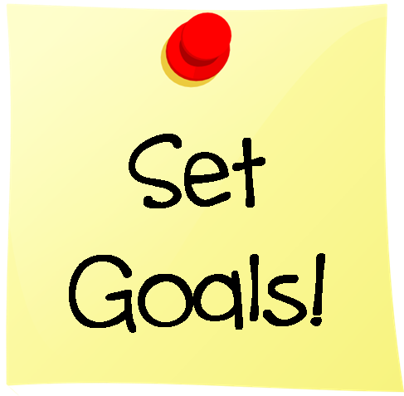
What would you like to do next year in 4-H (after you submit this project)? On a separate piece of paper, please use the guide below to plan your 4-H goals for next year. Include goals for your entire 4-H year as well as goals for this specific project. There is no page limit to this section.

ACTION RESULTS TIMETABLE
I want to learn how to eat healthier by December.
I want to give a 4-H presentation at DAD by June.
I want to train my dog to sit and stay before summer is over.

(Attach pages here)

For More Information

Visit our website: www.nc4h.org

Shannon B. McCollum, Ed.D
Extension 4-H Associate
shannon_mccollum@ncsu.edu
(919)515-8486

North Carolina State University and North Carolina A&T State University commit themselves to positive action to secure equal opportunity regardless of race, color, creed, national origin, religion, sex, age, veteran status or disability. In addition, the two Universities welcome all persons without regard to sexual orientation. North Carolina State University, North Carolina A&T State University, U.S. Department of Agriculture, and local governments cooperating.

