What is NC Safe Plates?

NC Safe Plates is a food safety certification course developed by North Carolina State University. Certification is provided by the National Registry of Food Safety Professionals.

Who should attend?

This is a comprehensive program for food service managers and supervisory staff in restaurants, hospitals, nursing homes, child-care facilities and other food handling establishments.

Successful completion of this course meets NC Food and Sanitation Regulation for food safety training.

You must be able to attend all three days and stay for the entire class

September 6 & 7, 2017
9:00am – 4:00pm
and
September 8, 2017
9:00am – 12 noon
at
Nash County Agriculture Center
1006 Eastern Ave, Room 102
Nashville, NC 27856

Registration Fee:
$125.00
Registration Deadline:
August 15, 2017

LATE REGISTRATION WILL NOT BE ACCEPTED

Registration includes book and snacks on Tuesday and Wednesday, the exam and certification.

You will have a 1 hour lunch break on Wednesday and Thursday. There are a variety of restaurants in the area, or you can pack a lunch, microwave and refrigerator available on site.

Tentative Schedule

Day 1
Introduction
Approved Suppliers
Pest Control
Storage
Preparation

Day 2
Personal Hygiene
Sanitary Facility Design
Service
Communication
Review for Exam

Day 3
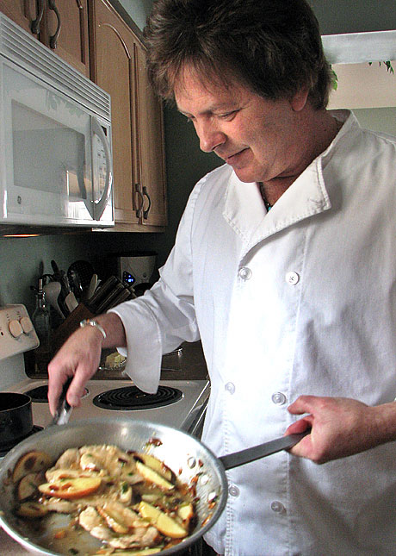
Certification Exam

Registration Form

Name:___________________ Business:__________________
Title:____________________
Address:__________________________________________
City:___________Zip:_______ Phone:___________________
Email:____________________

Circle the class you plan to attend:

September 6 - 8 in Nashville, NC

*Make checks payable to:
Nash County
*Mail registration and check to: NCCE-Nash County
ATTN: Jayne McBurney
1006 Eastern Ave.
Nashville, NC 27856

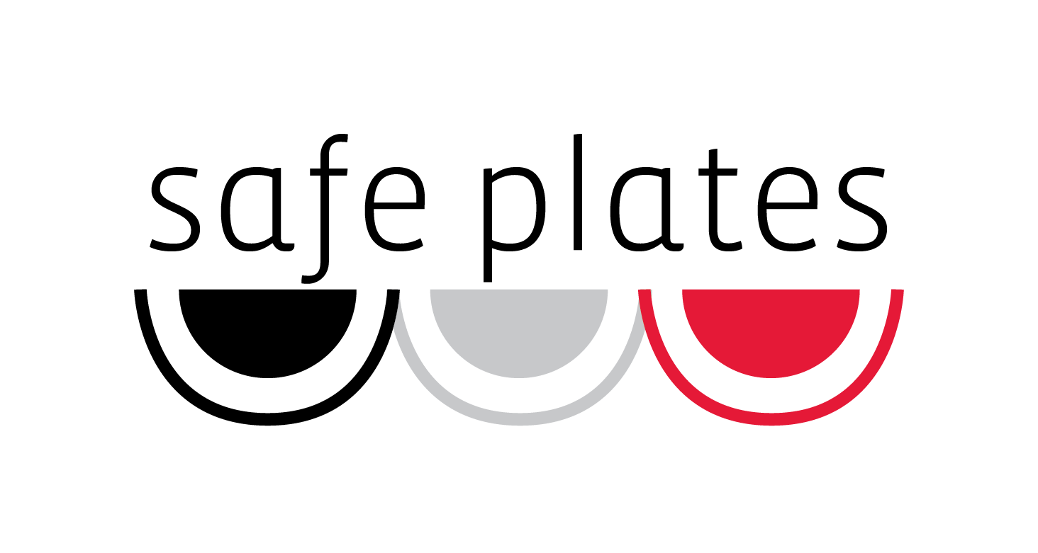
Questions?

Contact:
Jayne L. McBurney, M.S.
Nash County Extension Agent, Family & Consumer Sciences
1006 Eastern Ave, Room 102
Nashville, NC 27856
Phone 252.459.1405
jayne_mcburney@ncsu.edu

For accommodations for persons with disabilities, contact Jayne McBurney at 252-459-1405 no later than ten business days before the event.

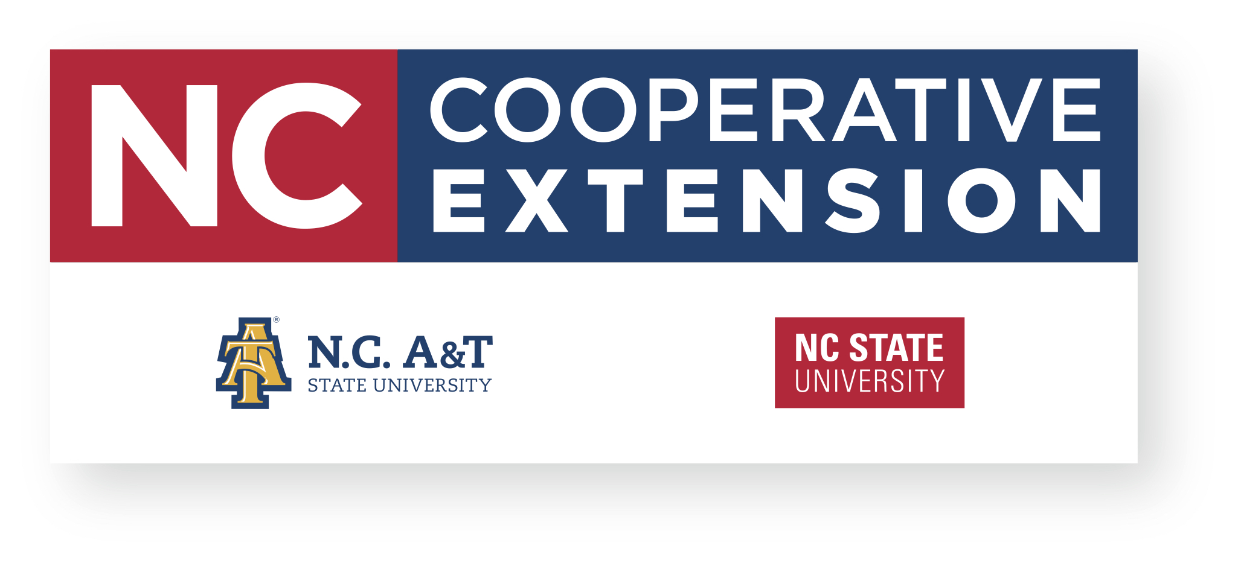

North Carolina State University and North Carolina A&T State University commit themselves to positive action to secure equal opportunity regardless of race, color, creed, national origin, religion, sex, age, veteran status or disability. In addition, the two Universities welcome all persons without regard to sexual orientation.

A Food Safety Certification Program for Food Service Managers and Supervisors
Upcoming class in
Nashville:
September 6-8, 2017

